MIFOS

**UPI in India**

Digital Impact Alliance

horizontal line

# 

# Introduction

In April 2016, National Payments Corporation of India with the support of Reserve Banks of India(RBI) and Indian Banks Association (IBA) launched an initiative known as Unified Payments Interface (UPI). It is because of UPI that online transactions have become much easier and online payments have increased by 200% in India.

# What is UPI?

Unified Payments Interface (UPI) is a system that powers multiple bank accounts into a single mobile application (of any participating bank), merging several banking features, seamless fund routing & merchant payments into one hood. It also caters to the “Peer to Peer” collect request which can be scheduled and paid as per requirement and convenience.

# 

# How Does it Work?

UPI is built on top of a platform called the National Financial Switch. With the help of this platform, it is possible to transfer money from one account of one bank to another account of another bank.

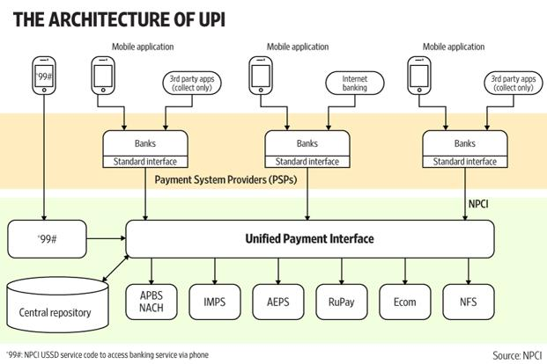

# How can a Normal User use UPI?

Users can download the BHIM UPI app to their smartphones and link their bank accounts to it. Users can also dial *99# to make transactions.

# But is it Making Any Difference?

Simply, YES. According to data released by the National Payments Corporation of India (NPCI), which runs the UPI platform, UPI transactions surged to 9.2 million in May from 6.9 million in April and 92,000 in August. The total value of UPI transactions shot up to Rs 27 billion in May from Rs 7 billion in December, a month after the government demonetised high-value banknotes.

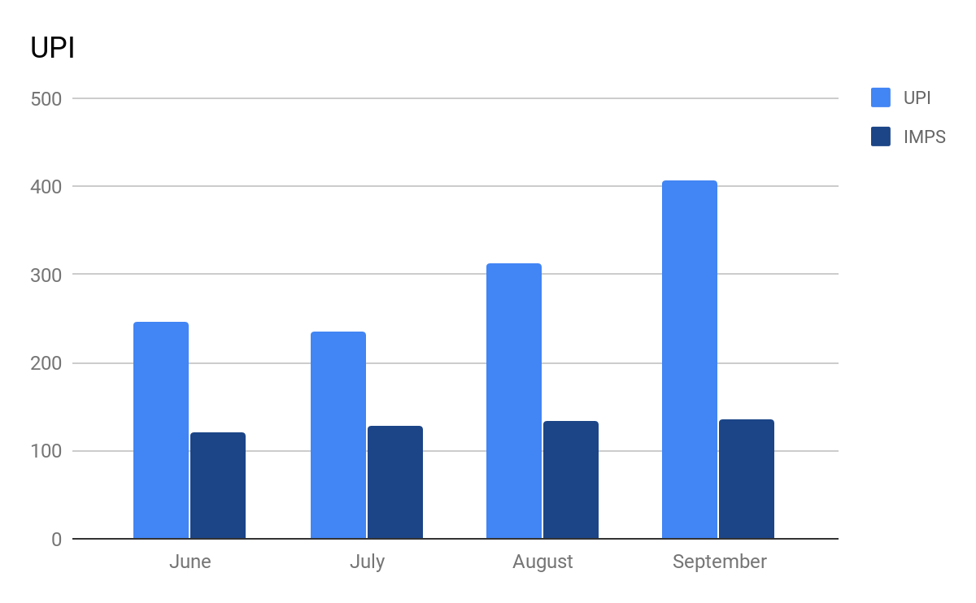

# Why is UPI growing so Popular?

Firstly, UPI is very simple to use. E-wallets involve multiple legs in a transaction whereas UPI is easy and straight forward to use. Another reason is that UPI does not require any KYC of any sort, if you are an Indian with a bank account, you are good to go. Moreover features like virtual addresses and 2-factor authentication make it a customer favourite.

# Is it a Mobile-wallets killer?

There has been a lot of speculation that UPI is the beginning of the end for mobile wallets. In my view, that is a very premature and uninformed contention, given that mobile wallet companies in India have more customers than any of the existing bank supported apps combined. Although, UPI holds tremendous potential and anything can happen.

## Advantages of UPI

### Minimal Charges and Instant

The biggest advantage of Unified Payment Interface is that there are no or minimal charges on the transactions done through UPI. So in case of NEFT and RTGS charges are in the form of bank commission and GST on that commission which is not the case with Unified Payment Interface. Also, funds are transferred instantly from one bank account to another bank account which is not possible in case of other modes of transfer like RTGS which takes 30 minutes to 2 hours for fund transfer or NEFT which takes 1 hour to 4 hours for fund transfer.

### No Need to Fill Details

Another advantage of UPI is that one does not need to fill the various details like ATM card number or account number or IFSC code rather one has to give only the virtual address to which funds have to be transferred. The virtual address can be in the form of ABCD@nameofthebank, so for example, if you want to transfer funds to your friend Mahesh and his account is in HDFC bank and his virtual address is Mahesh@HDFCbank than you have to input this virtual address and funds will be transferred instantly to his account.

### No need for Registration and always Available

In case of other modes of online funds transfer registration of new payee takes time while in case of UPI there is no need for registration of payee and one can transfer funds to the new payee instantly and also one can transfer funds at any time that is Unified Payment Interface is available 24 hours and also funds can be transferred even on Sundays and when there is a holiday in the bank.

## Disadvantages of UPI

### Transaction Limit

In case of UPI, there is transaction limit which varies from bank to bank but in the majority of banks, it is not more than 1 lakh while in case of other modes of transfer like internet banking, RTGS there is no limit and an individual can transfer any amount which he or she wants. Hence in simple words, UPI is ideal for smaller fund transfer, when an amount is high than other modes of online transfer are preferable.

### Requirement of Internet and Smartphone

Another problem with Unified Payment Interface is that since there is a new way of fund transfer many people are reluctant to use because of unknown fear associated with new things and also using smartphone and virtual address for funds transfer will be out of question for majority of the population of the country as majority of the population still do not have internet and smartphone which is necessary for transacting through UPI.

### Difficult to Convince the Customers

Another problem with UPI is that it is difficult to convince the customer to install the bank application in the mobile for Unified Payment Interface as the customer are afraid of online fraud and for them, terms like virtual address sound very technical and they will not even listen about the benefits of Unified Payment Interface.

Frequently Asked Questions

## What are the important features of UPI?

It is accessible 24*7 and 365 days. A single app can be used for different bank accounts. Customers can make virtual addresses, these virtual addresses of the customer for Pull & Push provide for incremental security with the customer not required to enter the details such as Card no, Account number; IFSC etc.

## What are Virtual Addresses?

UPI ID or VPA is a Virtual payment address which is used in place of bank account details for the fund transfer. This address is unique to every user. It is very flexible and you can change it. Since it is not your actual payment address but act as the payment address (bank account details), It is called the virtual payment address or VPA. The UPI ID resembles the email ID.

## How secure is UPI?

Every UPI transaction, irrespective of which app, goes through a leg of transaction which requires a (public key infrastructure) PKI-based encryption key usage and validation with the National Payments Corporation of India of the fingerprint of the mobile device and validation of a UPI PIN using a hardware security module, once in a complete end-to-end transaction.

## How Different is UPI from Mobile Wallets?

UPI do direct bank to bank money transfer but wallets act as an intermediary between two bank accounts i.e. you recharge your wallet from your bank account to use any services that a wallet provides. Also, UPI allows you to transact up to Rs. 1,00,000/- and in the case of wallets you can only store up to Rs. 10,000 (For non KYC customer).

## How is UPI different from pre-existing payment systems?

There are mainly 3 payment systems, IFSC, NEFT and RTGS. The funds transferred under NEFT method are settled in batches (based on Deferred Net Settlement (DNS) and at a specific time of the day. If the transfer is initiative beyond the cut-off time specified by RBI, the funds are typically settled on the next working day. RTGS comes with limits on the minimum and maximum fund value, however, it is efficiently used in situations where individuals and businesses require immediate settlement of high-value funds that are well within the specified limits. IMPS is used widely across most banks. Unlike other methods of fund transfer that become unavailable on bank holidays and during off working hours, IMPS functions 24/7 allowing a fund transfer at any time of the day. UPI is the cheapest of these all, it only costs INR 0.5 per transaction. Moreover, UPI is the most secure and supports transfer between different banks.

## 

## 

## What happens if one forgets their UPI pin?

Don’t panic because even if you don’t remember it, you can reset it easily. To reset your forgotten UPI PIN in Bhim app interface, go to home screen and then tap on accounts section. There you have an option for ‘Forgot UPI-PIN’. You can change and set a new pin for any of the bank accounts listed there. Although you will need your debit card details and registered mobile number.

## What happens if someone loses their phone which has UPI installed?

Even if you lose your phone and someone has access to it, you still don’t have to worry about it as long as that person does not know your set UPI PIN. UPI PIN is required to authenticate all the money sending transaction using the Bhim app. So in case of mobile theft, the person who has stolen your mobile won’t have your UPI PIN to transact using your bank account in Bhim App. Therefore, your details are money is completely safe even when you have lost your mobile phone.